Year 10 DVC: Development of Shelter Structure
The following architects use structure and form in different ways in their architecture. You will try developing your Shelter designs in some similar ways.

SANTIAGO CALATRAVA |  |  | TOYO ITO
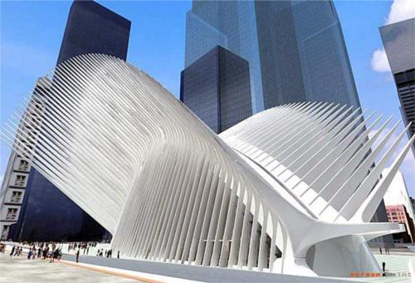  WTC Transit Station, New York, USA | 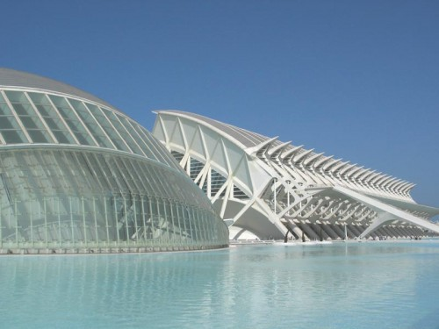  Valencia Arts and Sciences Centre, Spain | Descriptions… | 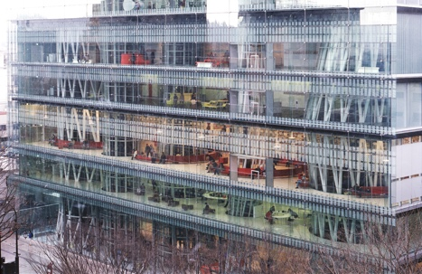  Sendai Mediatheque, Myagi, Japan | TOD’s Omotesando Building, Tokyo | Descriptions…
FRANK GEHRY |  |  | ZAHA HADID
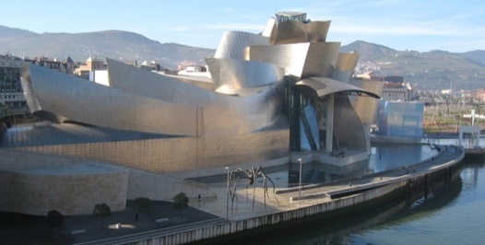  Guggenheim Museum, Bilbao, Spain | 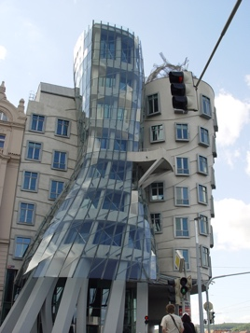  Dancing House, Prague, Czech Republic | Descriptions… | Cultural Centre, Baku, Azerbaijan | Abu Dhabi Performing Arts Centre | Descriptions…
NORMAN FOSTER |  |  | JOHN SCOTT
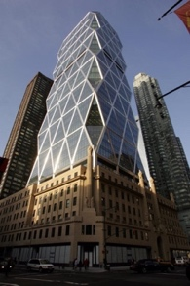  Hearst Tower, New York, USA | 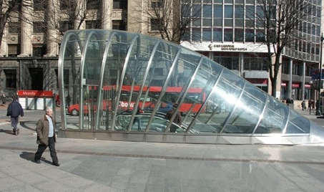  Metro entrances, Bilbao, Spain | Descriptions… | 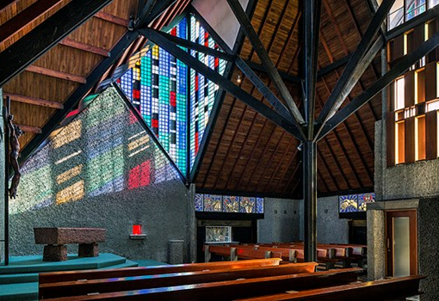  Futuna Chapel, Wellington | 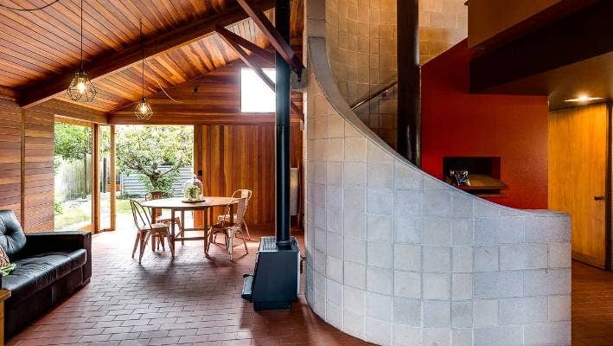  Arrowsmith House, Hawkes Bay | Descriptions…

